Your Name

Instructor Name

Course Number

Date

Molecular Biology of Cancer

**Question 1**

*Two-Hit Model of Carcinogenesis:* A two-hit model is a unified approach for analyzing the cancer patients infected with a “susceptible gene.” Fox Chase Cancer Center identifies Knudson’s “two-hit” cancer-gene model as a major leap in medical history; his model successfully explained the relationship between non-heredity and heredity of the cancer cells. According to his hypothesis, “Retinoblastoma can sporadically be formed in any human, but in some cases, it is due to the autosomal inheritance (“Knudson's Two-Hit Theory of Cancer Causation”).

In recent years, much debate has been stirred to study the mechanism of heredity and sporadic retinoblastoma. According to Othman and Ihab Saad, retinoblastoma is formed when the tumor copies the suppressed Rb-gene to a damaged cell. Conversely, sporadic disease depends on genetic change. People of any age group are susceptible to this gene; the heredity form of the disease results when the Rb-gene copy is inherited from its parents. The mutation of sporadic retinoblastoma is somatic: mutation is limited to the retinoblasts; whereas, mutation of heredity retinoblastoma is a germline- mutation limited to the healthy cells. In sporadic cancer, both rate and chances of spreading mutations are higher than the heredity retinoblastoma. For this reason, the rate of sporadic retinoblastoma in patients is almost 90% and that of heredity retinoblastoma is 5-10% (163–166).

**Question 2**

Genetic testing plays an essential role in the screening and risk assessment for breast cancer. The rapid expansion of genetic testing can contribute to the cancer diagnosis. The DNA test works by targeting the kinases and phosphatases, which are an integral part of oncogenes and tumor suppressor genes. The tests involve sample collection from the patient’s blood, saliva, or cells from the inner surface of the cheek. The collected sample is analyzed for the DNA sequencing by screening mutations, deletions or chromosomal rearrangements. Generally, a DNA test is only applicable to heredity mutations, whereas the genomic analysis is applied to the sequence of genomes inherited from BRCA1 and BRCA2. The DNA test may not yield the same result for sporadic breast cancer because analysis requires the part of tumor tissue.

**Question 3**

1. *Binding of the growth factor:* A growth factor is a type of secreted molecule that affects the cell growth by acting on the surface of the cell receptor that transmits the signals to intercellular components. In a healthy body, growth factors interact with specific receptors on the surface triggering cellular proliferation. In cancer patients, binding of the growth factor contributes to phenotypes by increasing the cellular growth, motility, and angiogenesis (Phin et al. 240). For example, surface receptor P13K can activate AKT, which a serine protein kinase.
2. *Invasion of blood vessels:* Blood vessels attached to the tumor are different from the healthy blood vessels in a way that tumor cells use their proteases to pass through the blood vessels; however, in a healthy blood vessel, there is no restriction in the blood flow. Mostly, cancer cells use macrophages to follow metastasizing cells. For example, tumor cells in epithelium can segregate near the basal lamina, which increases enough pressure to break the basal layer and invade the capillary, as indicated in Figure 1.

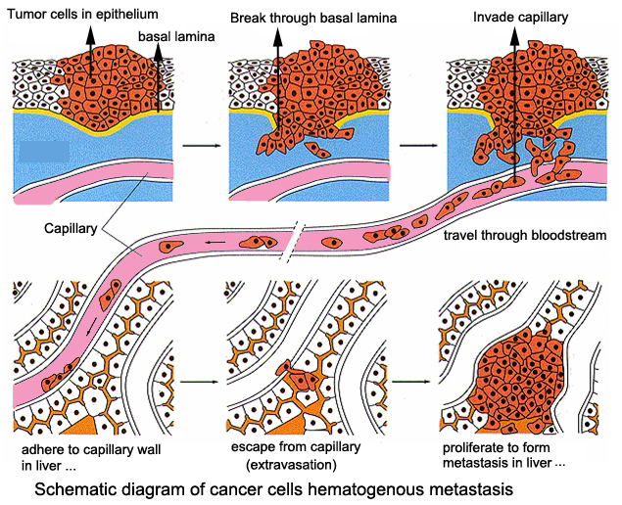

**Figure 1.** Schematic of blood vessel invasion during carcinogenesis. Source: Lecture 9, Slide 20

1. *Entry/Exit of Go of the cell cycle:* According to Nakanishi et al., the Go phase is the resting phase in the cell cycle, which exists as a quiescent state. In a healthy body, the Go phase can be regarded as an extended G1 phase, where cell functions by inhibiting their division. Even when the cells reach their maturity, they continue to perform the same function. In cancer patients, the Go phase indicates the cell exiting from the cycle, and this causes cells to reach their maximum capacity and become ‘senescent cells’, which are responsible for the abnormal mutation in the genes that control the cell manipulation (4352–56). For example, P130 protein has a link to the cell cycle exit and entry that promotes cell division in the cancer patients.

**Question 4.**

Three different types of mutations could lead to cell apoptosis are:

1. *CD-95/FAS:* Categorized under the down-regulated mutations, CD-95/FAS mutates the lymphoid and solid tumors. It initiates the extrinsic apoptotic pathway by binding itself with the H9, CH1, SKW6, and SW480 ligand that causes oligomerization of FAS and promotes tumor growth (Siegel et al. 469–74).
2. *TRAIL:* It is a down-regulate mutation in which the death receptor is bonded to DR4 and DR5 to activate the downstream caspases, leading to the activation of kinases. Lee et al. provide a comprehensive discussion that both TRAIL-R1 and R2 genes have been reported to map with the chromosome 8p21-22 that can cause Non-Hodgkin’s Lymphoma (401).
3. *CASPASE-8:* According to research on the mechanism of caspases-8 by Pecorino and Lauren, the mutation enters into the complex inhibitor and activates both intrinsic and extrinsic apoptotic pathways. Similar to other caspases, caspase-8 is formed as a single polypeptide and activates the proteolytic cleavage. It is known to propagate the apoptotic signal by activating other down-regulatory caspases (152).

**Question 5**

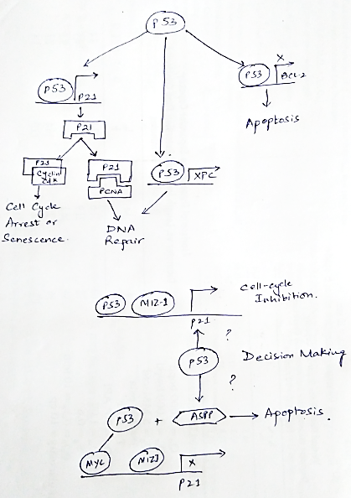

**Figure 2**. Schematic of the molecular pathway of p53 protein. Source Lecture 6, slide 20-24

1. The p53 protein is considered as “The Guardian of Genome” due to its ability to decide apoptosis, DNA repair, and cell cycle arrest. According to Figure 2, p53 is identified by its transcription factor that affects tumor-suppressing targets. The top section of the diagram illustrates the encoding of cyclin-cdk complexes by targeting p21 to prevent proliferation and DNA damage. In the DNA repair part, it targets the XPC gene and encodes the protein that repairs nucleotide. In downstream conditions, it targets many genes and promotes apoptosis.

**Question 6**

1. According to Leventaki et al., MDM2 and MDM4 have different but primary roles in p53 regulations. Both genes are structurally similar and are non-redundant to the p53 inhibitor. The MDM2 regulates the stability, and MDM4 governs the activation of p53 protein (763).
2. The presence of CDKN1A can help in regulating the p53 protein. Besides, the genetic lesion can also get affected by CDKN1A, as it is related to MDM4 regulation.
3. The main reason for testing RNA expression is due to undetectable nature CDKN1A through immunohistochemistry, which can produce a false-positive result.
4. As per observation, p53 protein was low in healthy cells as compared to CDKN1A; this is because they lack p53 may cause gain in MDM4, which contributes to the growth of mutations causing pediatric Burkitt Lymphoma (Leventaki et al., 771).
5. The correlative behavior in Figure A and C obeys the same rule that increasing the MDM4 expression may deregulate the p53 expression, which is s subset of pediatric Burkitt Lymphoma.

**Question 7**

Cancer stem cells are those found within the tumor and can form aggregates at an uncontrolled growth rate, whereas stem cells do not grow with such segregations are capable of producing more cells of the same type. The asymmetric cell division of the healthy steam cells produces two daughter cells. However, cancer cells carry more than 60 mutations, which spreads to other tissues and organs through metastasis. Pecorino and Lauren discussed two hypotheses for the cancer cells to be especially useful tumor cells, given as:

1. “Self-renewal increases the chances for the carcinogenetic change” (p.174).
2. “Changes in the process of self-renewal can lead to carcinogenesis” (p.174)

**Question 8**

Among various therapeutic methods for diagnosing cancer in the steam cells, anti-angiogenic therapies inhibit the migration of endothelial cells and proliferation. The WNT pathway offers better cancer steam cell eradication than other techniques by tracing the path of beta-catenin. The targetability of WNT signaling provides a promising to modulate tumor growth, cell senescence, and cell death (Kahn and Michael 513-17). Vascular Targeting (VT) is a novel therapeutic method that combines nanoparticles and gene therapy. It involves simple lipid-based nanoparticles, coated with a specific ligand that targets non-steam tumor cells. Glioblastoma is another technique applied to diagnose non-steam tumor cells; it works by regulating the core pathway of kinase receptors, suppressing the tumor signaling pathway. Common side-effects of both methods include heart damage, blood clotting, high blood pressure, hair-loss, change of skin color, loss of appetite, fever, vomiting, nausea, and damage to the organs.

**Question 9**

Our observation based on the given information in the question, indicate that the case of metastasis, which involves the process of cancer spreading from part to another. Having a tumor does not correlate the presence of cancer unless it developed a metastatic potential. There are several other routes through which cancer can spread into the blood and lymphatic system: The cancer cells circulating through the bloodstream can invade the capillary; cancer cells are often killed by white blood cells during their encounter; the majority of the cancer cells get stuck into the lymph glands, where they die due to malnutrition.

**Question 10**

1. *Interaction between primary tumor and future site of metastasis:* The primary tumor releases a signal comprising of Lysyl Oxidase (LOX) that induce the organ’s receptive regulation of fibronectin from the nearby fibroblasts. This leads to mobilize the progenitor cells, present in the bone marrow to the future sites of metastasis through cognate receptors.
2. *A micrometastasis that has NOT yet begun to grow:* The micrometastases may interact with the tumor by disseminating the carcinoma cells and rerouting the hematopoietic cells to different organs. During the initial stage of micrometastases, the cell deploys the complex mechanism that modifies the inner microenvironment to survive in different ectopic locations.
3. *A micrometastasis that leaves dormancy and begins to form a larger secondary tumor.:* According to the research conducted by Welch et al., when the micrometastasis leaves the dormancy and interacts to form a large secondary tumor, it creates the inability to engage in the with focal adhesion kinase (FAS). Moreover, it causes a disseminated tumor to escape from the dormancy and begin the active proliferation of the cell mechanism to a metastatic state. Mobilization of tumor marrow cells enters micrometastases may proliferate, counterbalancing the effect of the apoptotic rate (3026 and 27).

Work Cited

“Knudson's Two-Hit Theory of Cancer Causation.” *Fox Chase Cancer Center*, 12 Feb. 2018, [www.foxchase.org/about-us/history/discoveries-fox-chase-research/knudsons-two-hit-theory-cancer-causation](http://www.foxchase.org/about-us/history/discoveries-fox-chase-research/knudsons-two-hit-theory-cancer-causation). Accessed 03 April 2020.

Kahn, Michael. “Can We Safely Target the WNT Pathway?” *Nature Reviews Drug Discovery*, vol. 13, no. 7, 2014, pp. 513–17.

Lee, Sug Hyung, et al. “Somatic Mutations of TRAIL-Receptor 1 and TRAIL-Receptor 2 Genes in Non-Hodgkin’s Lymphoma.” *Oncogene*, vol. 20, no. 3, 2001, pp. 401.

Leventaki, Vasiliki, et al. “TP 53 Pathway Analysis in Paediatric B Urkitt Lymphoma Reveals Increased MDM 4 Expression as the Only TP 53 Pathway Abnormality Detected in a Subset of Cases.” *British Journal of Haematology*, vol. 158, no. 6 , 2012, pp. 763–71.

Nakanishi, Makoto, et al. “Exit from G0 and Entry into the Cell Cycle of Cells Expressing P21Sdi1 Antisense RNA.” *Proceedings of the National Academy of Sciences*, vol. 92, no. 10, 1995, pp. 4352–56.

Othman, Ihab Saad. “Retinoblastoma Major Review with Updates on Middle East Management Protocols.” *Saudi Journal of Ophthalmology*, vol. 26, no. 2, 2012, pp. 163–166.

Pecorino, Lauren. *Molecular Biology of Cancer: Mechanisms, Targets, and Therapeutics*. Oxford university press, 2012, pp. 152 and174.

Phin, Sopheap, et al. “Genomic Rearrangements of PTEN in Prostate Cancer.” *Frontiers in Oncology*, vol. 3, 2013, p. 240.

Siegel, Richard M., et al. “The Multifaceted Role of Fas Signaling in Immune Cell Homeostasis and Autoimmunity.” *Nature Immunology*, vol. 1, no. 6, 2000, pp. 469–74.

Welch, Danny R., and Douglas R. Hurst. “Defining the Hallmarks of Metastasis.” *Cancer Research*, vol. 79, no. 12, pp. 3026-27.